- Pinged google.com
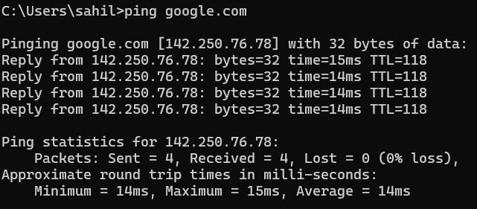
- Filters

- IP
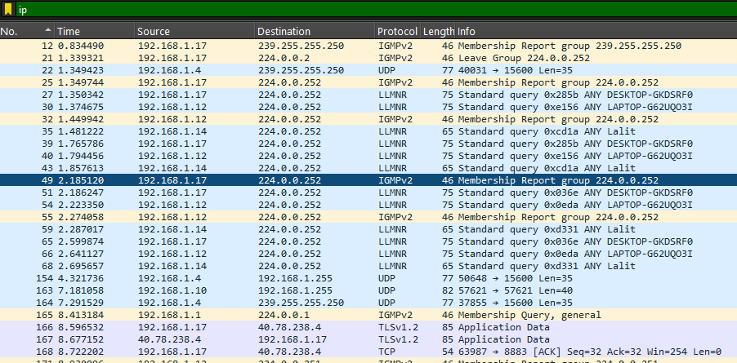
- TCP

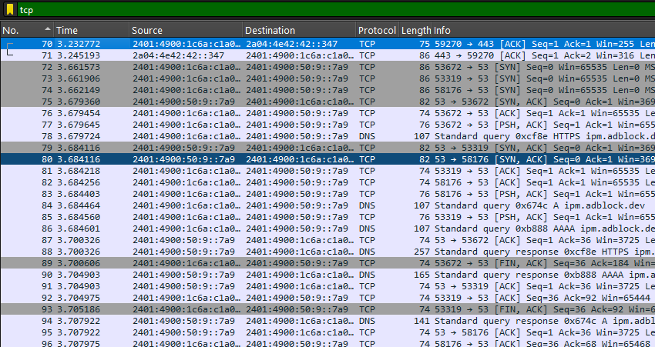

- UDP

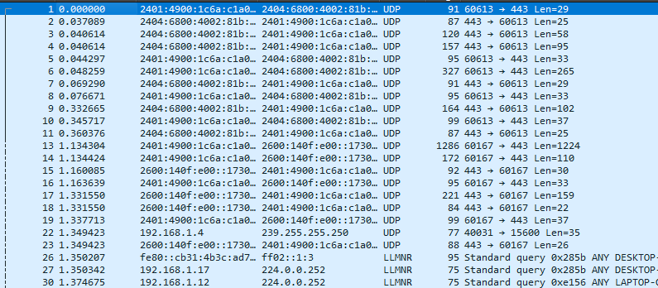

- DNS
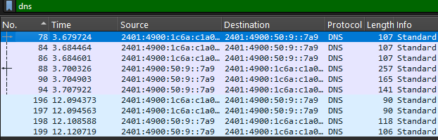

- Analyse a packet

- Ethernet header
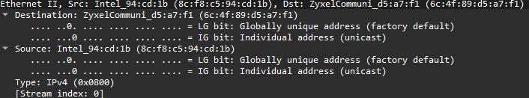

- IP header

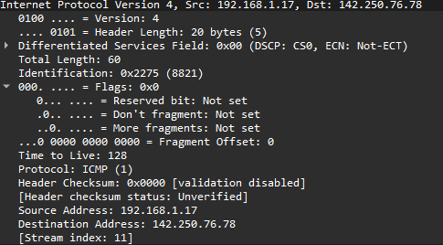
- TCP header

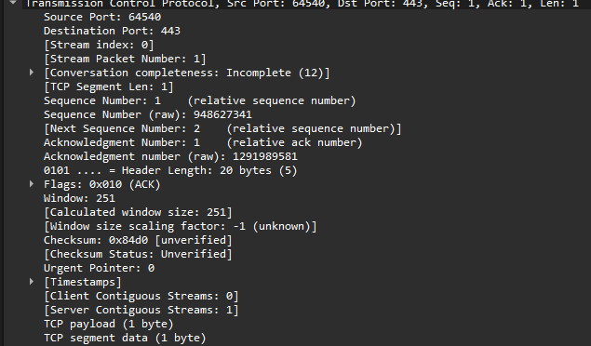

- Payload data
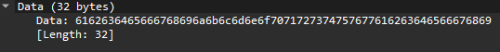

- Observations

- Interface used: Wifi
- Protocols observed: ICMP, TCP, UDP, ICMPv6, MDP, etc
- Source and Destination IP address: 192.168.1.17 – 142.250.76.78
- Packet Length: 32 byte (32 * 8 = 256 bits)

